**Project Title:**

Conducting a comparative study on health and sanitation data in Afghanistan and Senegal across 2-year time points.

**Project Proposal Summary:**

1. **Project Overview**

Our project seeks to conduct a comprehensive study on the dynamics of health and sanitation in Afghanistan and Senegal across two critical time points: 2011 and 2015.

We aim to identify and understand the trends, challenges and improvements in health and sanitation sectors in these two diverse regions.

The study is motivated by the need to access the progress made over this time span (4 years) to provide insight that can inform strategies and future decision-making in contributing to the advancement of public health and sanitation practices in both Afghanistan and Senegal.

1. **Project Hypothesis**

We hypothesize that the access to basic drinking water and sanitation services plays a critical role in reducing the prevalence of acute respiratory infections and fever among children under 5 in Afghanistan and Senegal, which in turn, may have a direct and measurable impact on reducing the mortality rate of this age group.

Over the time span of 4 years, we expect to observe improvements in health and sanitation sector outcomes.

We predict that mortality rate of children under the age of 5 will decrease and increase life expectancy in regions with better access to healthcare and sanitation infrastructure.

1. **Analysis Methodology**

Our project uses the data provided through the World Bank Organisation website, collecting the necessary dataset that includes the range of indicators related to health and sanitation sectors for the years 2011 and 2015.

The collected data will undergo data cleaning and processing to address missing values, outliers, and data inconsistencies. This helps to ensure data quality and reliability for subsequent analysis.

Time series analysis will help to evaluate how health and sanitation indicators have evolved over time. This analysis will help to identify patterns and trends.

Data visualization by using bar charts and graphs will create presentable findings in a visually compelling way. It helps make communicating complex data patterns to a broader audience.

1. **Conclusion**

**Afghanistan 2011 - 2015**

The data set shows an improvement in access to drinking water services and basic sanitation services from 2011 to 2014. This in turn, shows the decrease in open defecation practices and mortality rate for children under the age of 5s. There is a correlation of impact in improvement of health and sanitation sector with decreasing open defecation practices. The improvement in both the sectors also reduces the mortality rate for children under the age of 5s.

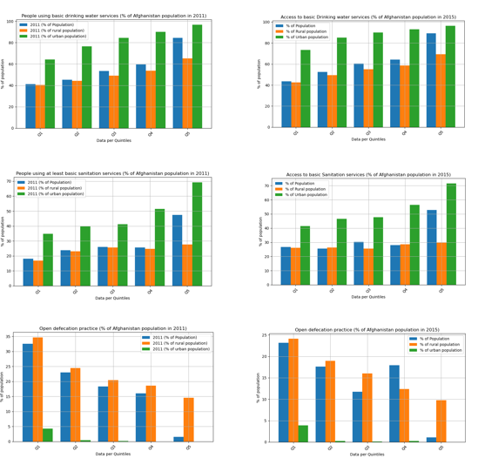

* Rural access to bathroom facilities, basic drinking water and sanitation services are significantly lower (orange) than that of the population in urban areas (green).
* The difference of access to such basic human needs between both areas are significant enough to be alarming, especially in the practice of open defecation. The percentage of rural population practicing this due to lack of bathroom facilities is around 15-35% as opposed to in urban being below 5%.

* Prevalence of ARI (due to lack of sanitary services and access to bathroom facilities) are around 18-20% in 2011, which has reduced to 10-18% in 2015.
* Prevalence of diarrhea (due to lack of access to drinking water, amongst other things not discussed here) was reported to be around 20% in 2011 across the quintiles, which has since dropped to 10-15% in 2015.
* Treatments of both diseases are reported to be provided to only ~50-70% of the affected children, leaving the rest without proper health care.

The prevalence of ARI and diarrhea, combined with the low level of treatment provided to the affected patients and lack of clean water and sanitary services access to the population has resulted in a devastating blow on the mortality of children under 5 in Afghanistan. 2011 consistently illustrates the percentage of mortality (per 1,000 live births) being from 85-118% while 2015 shows the numbers to fall to 40-80% mortality.

**Senegal 2011 – 2015**

The data set shows an improvement in access to drinking water services and basic sanitation services from 2011 to 2014. This in turn, shows the decrease in open defecation practices and mortality rate for children under the age of 5s. There is a correlation of impact in improvement of health and sanitation sector with decreasing open defecation practices. The improvement in both the sectors also reduces the mortality rate for children under the age of 5s.

As the population is divided into Quintiles, there are significant increase in the access to drinking water over the period of four years. The urban population have better access compared to the rural region with an increment of 5-7% across the rural population.

The charts depict the correlation between the open defecation practices and access to sanitation services over the period of 2011-2015. Since the sanitation services improved for both urban and rural population, open defecation practices decrease in Senegal.

Prevalence of ARI disease and diarrhea shows a slight decrease of about 5-7% between 2011 to 2015. Improvements of health and sanitation services shows an upward trend of treatment in ARI over the period of 2011-2015 which correlates to diarrhea prevalence and treatment decreasing in 2015.

Low basic sanitation and drinking water services in 2011 contribute to the mortality rate under 5 (per 1000 live births) in Senegal, there might be other contributing factors, but we have seen decline in 2015 that showcase positive point. The first Quintile shows 119% mortality rate in 2011 that decreased to about 85% in 2015.

1. **Limitations of data**

There are a few factors limiting the data. The use of quantile data set limits the research as no aggregation analysis such as mean, median and sum can be populated to improve the significance of health and sanitation improvements between the 2 countries across the year 2011 and 2015.

Other limitations include the lack of finding co-efficient values, p-values, and the z-values of the data to help solidify the analysis. The lack of comprehensive data impacts the statistical analysis including the calculation of p-values.

There are other factors that can be used to strengthen the correlation between the health and sanitation sector such as economic crises, political instability, or humanitarian crises as that may impact the health and sanitation sector. However, this could also be challenging to account for in the analysis.

1. **Team**

Our project is led by a team of 4 professionals undergoing the Monash Data Analysis Bootcamp, currently in week 7 and using past modules to create a conclusive data analysis.

Project members:

Choon Sien Wong

Ekjyot Kaur

Parminder Basra

Sohaila Nazari

**7. Resources**

<https://waterpeacesecurity.org/info/blog-08-16-2021-water-and-in-security-in-afghanistan-as-the-taliban-take-over>

<https://www.worldbank.org/en/results/2018/07/03/senegal-increasing-access-to-sustainable-water-and-sanitation-services>

<https://www.worldbank.org/en/country/afghanistan/brief/afghanistan-emergency-support>